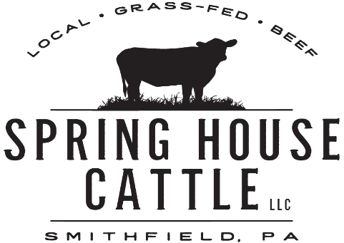

Buying Terms and Conditions

Welcome to Spring House Cattle, LLC., and thank you for buying your beef with us! We are proud to serve you with natural, healthy, grass-fed beef and outstanding customer service! Please take a few minutes to read over our terms and conditions surrounding your buying experience.

When ordering with Spring House Cattle, LLC., the buyer is responsible for two payments. In order to officially reserve a beef order, the buyer must send a non-refundable deposit of one of the amounts that corresponds to the quantity of beef being purchased, along with this signed document to Spring House Cattle, LLC., as follows:

$1,700.00 - whole beef
$ 850.00 – ½ beef
$ 550.00 – ¼ beef

*This deposit is not an external fee, nor is it an additional fee to the buyer’s total bill.*
This deposit counts as a credit towards the buyer’s total bill. Upon delivery of the buyer’s beef order, the remaining balance of the buyer’s bill must be paid in full. The remaining balance of a buyer’s bill is the full bill amount less whichever deposit that has previously been made.
In the event that Spring House Cattle, LLC. is not able to provide the buyer’s ordered beef quantity, the buyer’s deposit will be refunded. Solely under this circumstance will a buyer receive his/her deposit back from Spring House Cattle, LLC.
Upon receipt of your deposit and this signed document, Spring House Cattle, LLC. will promptly and officially reserve your beef order. Spring House Cattle, LLC. acknowledges its contractual responsibility to provide you, the buyer, with your beef order in exchange for the payment of the total bill.
By signing and returning this document and including a deposit that corresponds to your specific beef order to:

Spring House Cattle, LLC.
147 Grimplin Road
Vanderbilt, PA 15486

You, the buyer, agree to Spring House Cattle, LLC.’s buying terms and conditions as delineated above.

Buyer Printed Name:________________________

Buyer Signature:________________________ Date: _____________

Buyer’s Purchased Beef Quantity:_____________________________________
(1/4 beef, ½ beef, whole beef)

